Fashionable Indian Party Wear For Women (2026 Style Guide)
By Sugandh Gupta | September 7, 2026
Party wear is kinda where fashion gets to be a little playful, you know. It’s not like wedding dressing or office stuff, so the rules are fewer, which is probably why finding fashionable Indian party wear for women can feel weirdly overwhelming, always. One week it’s kaftans , then statement shirts, fusion dresses, co-ord sets too, and somehow it keeps snowballing every season, like no one told it to stop.
In this sorta guide, I break down party wear by occasion, fabric and silhouette, so you can build a party wardrobe that actually works for a Friday dinner, a cousin’s sangeet, or a rooftop birthday bash… without having to buy a whole new outfit for every single little thing.
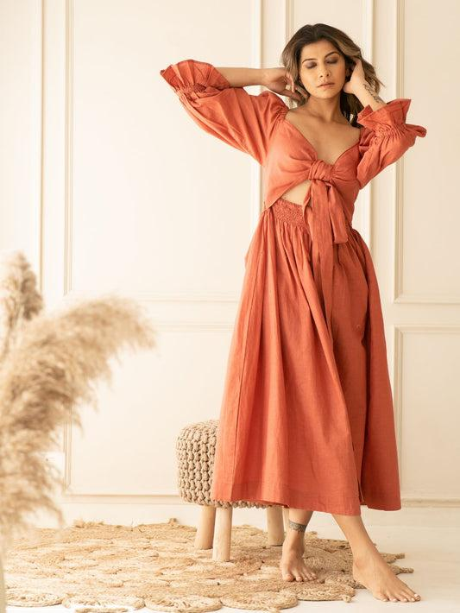
Why fashionable party wear deserves its own wardrobe rules
Daily wear is comfort-first, office wear is more polished, but fashionable Indian party wear for women is mainly supposed to do one thing really well: make an entrance. So yeah, that usually means bolder colors, more texture , and silhouettes that look good while you move… and also photograph nicely, because that’s kinda part of it now.
Still, fashionable party wear that only looks good in photos, and then pinches or sits awkward, it kind of defeats the point. The best pieces do a balance between drama and wearability-fabrics that move, necklines that flatter, and detailing that catches the light, without making it feel like your outfit is quietly heavy on you all night.

Types of fashionable Indian party wear for women
A party wardrobe works best when you rotate different silhouettes, not like, five nearly identical dresses in different shades. So here are the categories to keep on repeat.
Kaftans for easy party glam
Kaftans have basically become one of the most requested styles of fashionable party wear, and it kinda makes sense. One flowing silhouette, minimal effort, instant drama. Floral kaftans or rose-print ones in aqua, black, and olive tones feel especially right for evening meetups and destination plans, honestly.
Statement shirts and tops
A well-cut shirt in a jewel tone, or a floral print, has turned into a party staple on its own. Wear it with tailored pants or a satin skirt and you’re basically done. If you can, look for subtle embroidery or a printed yoke, those little touches that shift a shirt from office-ready into fashionable Indian party wear for women… without adding extra bulk.
Anarkali and fusion dresses
If you’re feeling a bit more traditional, Anarkali-style dresses, and Indo-Western fusion cuts are a steady pick. They bring that volume and movement ethnic styles have, but it still feels like you’re wearing one piece, so it’s less complicated. That’s why they land well for sangeets, cocktail parties, and even festive family dinners.

Co-ord sets and midi dresses
Matching co-ord sets, plus midi-length dresses, complete a fashionable party wear wardrobe for nights when you want a more structured vibe , not just a flowy moment. A metallic or sequined co-ord set is extra good for cocktail season. And if you want dressier but still clean and simple, a well-tailored midi normally does the job for smaller dinner plans.
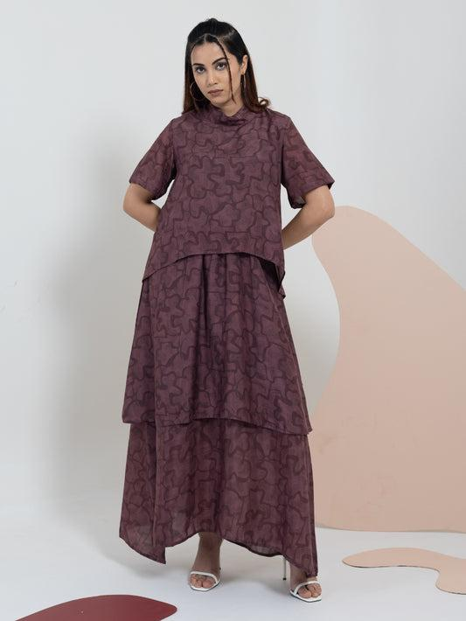
Choosing fashionable party wear by occasion
Not every party is the same kind of fun. Here’s how to match your outfit energy to what’s happening.
Daytime brunches and garden parties
Lightweight fabrics and softer shades are usually the move. A floral shirt with wide-leg pants, or a pastel kaftan gives you fashionable party wear that feels relaxed, not like you accidentally overdressed.
Cocktail nights and evening parties
This is where you can get louder: sequins, metallics, deep jewel tones, structured shapes too. A co-ord set, or a fitted midi dress with statement jewelry, makes confident fashionable Indian party wear for women for evening events , no overthinking required.
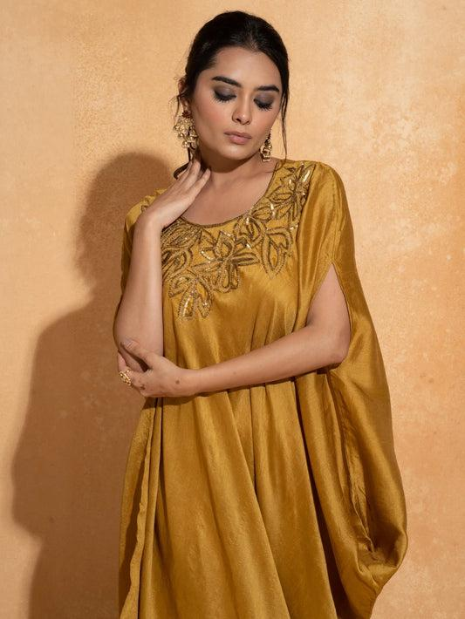
Festive and family celebrations
For sangeets, family get-togethers, or festive dinners, Anarkali dresses or richly detailed kaftans fit the sweet spot. They blend traditional with something current, so you can stay comfortable around older relatives… but still stand out in photos.
Fabric and detailing guide for party wear
● Georgette and crepe: Lightweight, and usually less likely to wrinkle, so they’re great for travel-friendly fashionable party wear.
● Silk and satin: Adds that natural shine, especially ideal for evening events and cocktail nights.
● Sequins and metallic threadwork: Works best when kept in smaller portions, like necklines, borders, or panels, so the whole outfit still looks good in mixed lighting.
● Printed cottons: A breathable, practical pick for daytime parties, especially if the weather is warmer.

How to style fashionable Indian party wear for women
● If your outfit is already heavily printed or embellished, keep jewelry more minimal, so everything doesn’t start competing.
● Layer a structured jacket or a cape over a simple dress, and it basically upgrades daytime fashionable party wear for nighttime use.
● If you’ll be standing or dancing for hours, block heels or embellished flats are usually safer.
● Keep makeup softer for daytime , then for night go a bit bolder—deeper lip or a metallic eye, something like that.

Accessorizing tips for party wear
● Statement earrings look best when the neckline is simpler; if your outfit already has embellishment, keep your neck jewelry light.
● A structured metallic clutch or box bag tends to work better than an oversized everyday bag.
● Pick one dominant metal-gold or silver-and repeat it across jewelry and footwear, so the look feels cohesive and not random.

Caring for your fashionable party wear
● Dry clean pieces with sequins, metallic threadwork, or delicate embroidery, so they don’t get damaged from regular washing.
● Store kaftans and flowy dresses on padded hangers, to help keep their shape between wears.
● Keep embellished items in breathable garment bags, away from direct sunlight, so the sequins and threadwork don’t dull too quickly.

Frequently Asked Questions
What makes an outfit count as fashionable party wear rather than just regular clothing?
Usually it’s the whole vibe, not only the cut. Fashionable party wear tends to lean on richer fabrics, bolder tones, and extra detailing like sequins, embroidery, or metallic touches. It also feels shaped to show up nicely under evening lighting, and yes in photos too, so it doesn’t look “meh” when the flash hits.
Can the same outfit work for both daytime and evening parties?
Honestly, often yes. A lot of fashionable Indian party wear for women is super flexible. You can switch flats for heels, pop on a statement earring, and go a bit deeper with your lip color, then it turns from daytime-ready into full evening energy. Sort of quick, but it works.
Which fabric is best for destination parties or weekend trips?
If you’re traveling, georgette and crepe blends are usually the easiest win. They hold their shape better, resist wrinkles, and they pack without taking over your suitcase space. That makes them a travel-friendly, fashionable party wear kind of fabric.
How many party outfits should I have at a given time?
A small collection works best, like three to four items. Think one kaftan, one structured dress or co-ord set, one statement shirt, and one Anarkali or fusion dress. This way you can handle most invites, without wearing the same silhouette again and again.
Final Thoughts
Building a wardrobe of fashionable Indian party wear for women doesn’t mean collecting outfits that you only wear once. You really can get by with a handful of versatile, well-made pieces. Like a kaftan, a statement shirt, a fusion dress, and a co-ord set. Those can carry you through most parties on your calendar, without stress.
Go ahead and explore the full party wear collection curated by World of Sugandh, to find pieces that match your next celebration. And if you already know the look you want, you can browse specific edits, like party wear dresses and Indo-Western dresses, for an easier pick.

About the Author
Sugandh is a fashion writer who’s passionate about all things Indian ethnic and fusion wear. With over 8 years of experience, the focus is festive and party styling-so it’s never random. For more, read the About Us page, or follow along on Instagram and YouTube.

