Bold Fashionable Party Wear , a stylish guide to choosing the right party outfit
Party dressing is not just about wearing something eye-catching it is more like you need to feel sure of yourself, polished and comfy, plus you know that little party-ready presence that happens almost instantly. That is kind of where Bold Fashionable Party Wear steps in, because instead of chasing every passing trend you pick one or two strong style cues , like an expressive colour, a standout embroidery , a neat silhouette or a interesting fabric … and then let that basically do most of the talking
For women who are looking for Stylish party wear dresses , the options now are beyond the usual “just a dress and done” situation. Flowing kaftans , statement shirts, contemporary dresses, coordinated sets , and even ethnic-inspired shapes can all fit well for celebrations, dinner scenes, cocktail evenings and social meetups. Still , it comes down to what suits the occasion, your comfort level, and the impression you want to leave behind
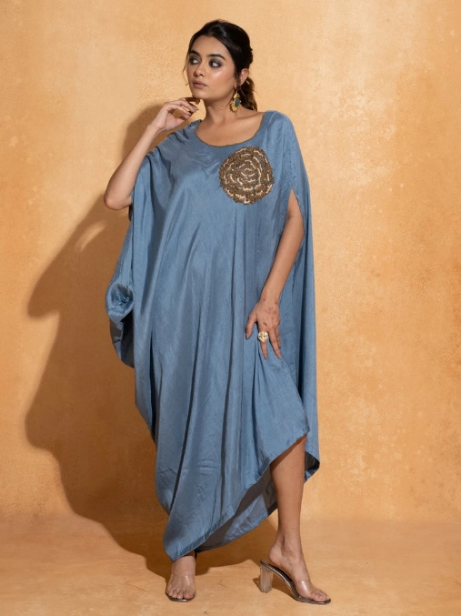
What Makes Bold Fashionable Party Wear Stand Out?
Bold fashion does not always mean the brightest colour or the loudest outfit in the room. A smarter approach is to let one defining feature lead everything else, ok, you know what i mean
A statement piece can pop thanks to its colour, embroidery, print, neckline, silhouette or fabric finish. Then the rest of your styling can stay fairly clean, so the look feels intentional not overloaded
For example, a richly embroidered black shirt can become the focal point of an evening look without needing a million accessories. A flowing blue kaftan can create real visual impact mainly through silhouette and detailing. Or a mustard-toned flowing dress can make a statement just by colour and movement
The party-wear collection at World of Sugandh includes a broad mix of kaftans, dresses, shirts, kurtas, co-ord sets, midi styles, and other occasion focused silhouettes. So shoppers have more freedom to match their vibe, not only one fixed category

Choose Your Party Outfit According to the Occasion
The same outfit doesn’t really have to work for every single celebration. If you understand the setting first, styling becomes easier, almost by itself

Dinner Parties and Evening Gatherings
Evening events usually suit darker shades, refined embroidery and fabrics with a subtle sheen. Black, navy, deep blue and other rich tones can feel sophisticated without going overly formal in Bold Fashionable Party Wear
Also , a shirt-based outfit can be surprisingly good for dinner. The Noir Elegance Shirt works as an example: it is a black loose-fit shirt with a shirt collar and tonal bead embroidery. The cotton-silk fabric and the understated detailing help it feel elegant, not excessively decorated

Cocktail Events and Night Parties
If the vibe is more glamorous, go for silhouettes that create movement or have a clear design highlight. A flowing dress, kaftan or statement shirt can bring that evening drama, but it can still be easier to wear than very structured clothing
The Midnight Allure Shirt is a navy loose-fit option with a shirt collar and thread embroidery inspired by sunburst forms. The satin-cotton blend gives it a polished look while keeping the shape fluid in Bold Fashionable Party Wear.
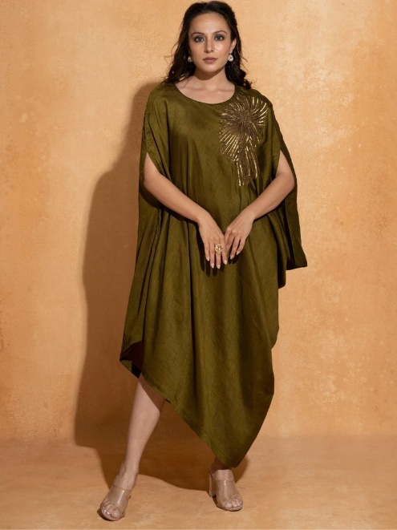
Daytime Celebrations
For daytime events, lighter colours and softer styling usually sit better. You want silhouettes that feel light, not heavy
A bright dress or a floral-inspired shirt can add personality without making the outfit feel too formal in Bold Fashionable Party Wear
For daytime styling, the Rose Reverie Shirt is a softer option. It is listed in peach with a shirt collar and loose fit, and the cotton-silk fabric has delicate embroidery in lilac, ivory and gold

Stylish Party Wear Dresses: Find the Right Silhouette
Silhouette matters a lot for how an outfit looks and how it feels too. Instead of picking something only because it is trending, think about the amount of movement, structure, and coverage you want
Flowing Dresses for Effortless Movement
A flowing dress can create an elegant party look without complicated styling. The garment moves with you, and that movement becomes part of the overall effect
The High Flow Dress comes in mustard yellow, and it is available in sizes S, M, L and XL. The product page doesn’t currently list filled-in details for fabric, neckline or fit , so don’t assume those specifics before purchase
This is also a helpful online shopping reminder, because relying on real product details is smarter than assuming every dress in a collection is made the same way or fits the same

Kaftans for Relaxed Party Glamour
Kaftans are especially useful when you want a statement silhouette but still want freedom. Their flowing shape looks elevated while avoiding the tight or restrictive feeling that some fitted party outfits can create
The Aqua Blue Single Rose Kaftan is a good example. It is a blue anti-fit kaftan with a boat neckline, silk fabric and a single rose embroidery detail. It comes in Free Size in Bold Fashionable Party Wear
This party-wear collection also includes other kaftan options, and kaftans are one of the biggest categories currently shown on the collection page

Statement Shirts for Contemporary Party Dressing
Party dressing doesn’t have to be only dresses. A detailed shirt can become the centre of your outfit when you style it with the right bottom, footwear, and accessories
The Azure Bloom Silk Shirt leans into a more expressive direction with denim-blue colouring and maroon floral embroidery. The product page mentions a loose fit , shirt collar and a silky cotton-satin blend , so the whole style feels modern
Pieces like this are a great match for women who prefer modern separates, instead of only one-piece party outfits
Buy Women Party Dresses Online in India: What Should You Check?
When you buy women party dresses online in India , the main mistake is usually deciding only from the photograph , you know just that one moment, then boom. No touching the fabric, no quick trial in front of the mirror, so the product-page info sort of becomes everything… and you should actually read it in Bold Fashionable Party Wear.

Check the Size Information

Don’t depend only on what the model looks like. Look for the real measurements or the size chart that’s given with the listing.
The Bold Fashionable party-wear collection right now commonly has sizes like S , M , L, XL along with 2XL for some items, and Free Size for lots of other pieces. But yes, availability can change from product to product.
Also, different products can fit in very different ways. For instance, High Flow Dress is listed in S through XL, while Aqua Blue Single Rose Kaftan is shown as Free Size.

Read the Fabric Details
Fabric impacts how an outfit actually looks, how it moves, and how it feels on you. It can even change the whole “vibe to Bold Fashionable Party Wear” of the same cut, even if two dresses look similar.
Example: Noir Elegance Shirt lists cotton silk fabric, and Aqua Blue Single Rose Kaftan lists silk. Rose Reverie Shirt is also shown with cotton-silk fabric
So instead of assuming “what it probably is” from the appearance, check the product information first.
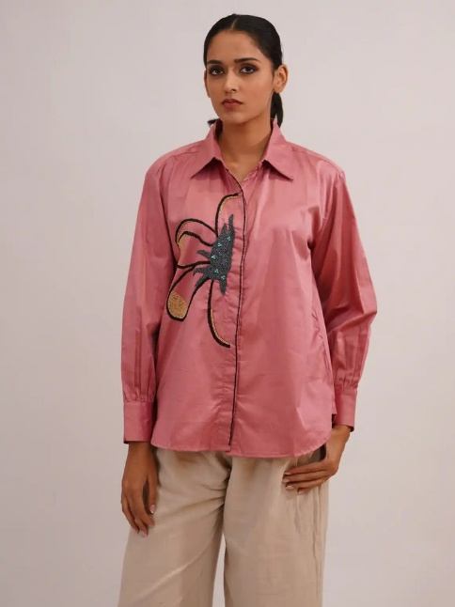
Look at the Design Details
Small things like embroidery, neckline, and the way it fits can completely shift how the outfit works for the event.
A shirt collar gives a different impression than a boat neckline. A relaxed silhouette can look very different from a body-skimming shape. And embroidery can become the entire focus, even if the rest of the outfit is kept simple.
These little details matter a lot when choosing Stylish party wear dresses online , because they help you see whether the garment matches your preferred style in real life.

Finding Affordable Party Dresses Online Without Losing the Look
Finding affordable party dresses online doesn’t have to mean you only pick the cheapest option that exists in Bold Fashionable Party Wear.
A better plan is to think about how often you’ll wear it, and where exactly you’ll use it.
If the piece can be styled in more than one way, it may end up being more valuable than a super specific trend that you’ll wear once.

Before you purchase, consider:
• Choose a design that can work in more than one styling direction
• Look for finishing details that add personality , but don’t make accessorising annoying
• Check whether the silhouette feels right for day as well as evening
• Read fabric plus care instructions before deciding
• Compare garment measurements with something you already own
• Think realistically about how often you’ll wear it
A good party outfit shouldn’t feel like a one-event purchase, if it can actually fit into your wider wardrobe plan.

How to Style Bold Fashionable Party Wear Without Overdoing It
A simple trick for making a bold look feel polished is to avoid “competing” with it.
If the outfit already has clear embroidery , keep jewelry more refined. If the clothing has a strong color, go for neutral or metallic accessories. If the silhouette is dramatic, choose simpler footwear and a cleaner bag.
Like, a richly detailed shirt can be matched with understated bottoms and minimal jewelry. A statement kaftan often needs only elegant earrings, and refined footwear. A bright flowing dress can stay the main focus , if the accessories are kept streamlined.
The point isn’t to make every single part of your outfit loud. The point is to build one strong visual story.

Choosing Colours for Party Dressing
Colour can instantly change the mood of what you wear.
Black and navy can create a sophisticated evening appearance. Blue can feel fresh and expressive. Mustard and other warm shades bring energy for daytime celebrations. Softer peach and pastel tones can create a lighter, more delicate party look.
This collection reflects that variety, with colours like black, blue, bronze, brown, green, navy, orange, pink, purple, red, white and yellow showing up across different product listings.
Instead of picking a colour only because it’s “in fashion, Stylish party wear dresses” think about when you’ll wear it, and what accessories you already have at home.

Build a Party Wardrobe Instead of Buying One-Off Outfits

A practical party wardrobe should include different kinds of pieces, not just several items that all do the same job in Stylish party wear dresses.

A useful mix might include:
1. A statement dress for the most important evening moments
2. A flowing kaftan for easy celebrations
3. A sophisticated shirt for a modern styling vibe
4. A versatile outfit in a strong colour
5. A softer-toned piece for daytime get-togethers
This method gives you more styling flexibility, and it becomes easier to create new looks without constantly buying something entirely new.
The World of Sugandh party-wear collection itself follows this range too, with dresses, kaftans, kurtas, shirts and tops, co-ord sets, midi styles, Anarkali sets and sharara sets.

A Simple Checklist Before You Buy

Before you place an order for women’s party dresses , pause and ask yourself:
• Does the silhouette match the kind of event?
• Is the colour something I will genuinely enjoy wearing?
• Have I checked the exact size or the measurements
• Is the fabric clearly mentioned
• Does the neckline or collar match how I like to style outfits?
• Is the detailing enough to feel special , without being hard to accessorise?
• Can I wear this outfit again for another occasion?
• Does the product page actually provide the information I need?
These questions can make online shopping more intentional, and reduce that urge to buy something just because it looks impressive in a picture to Stylish party wear dresses.

Frequently Asked Questions

What is Bold Fashionable Party Wear?
Bold Fashionable Party Wear basically means clothing made to look noticeable and self assured, usually through colour, embroidery, print, silhouette or fabric finish. The boldest looks tend to lean on one or two standout features, instead of stacking too many dramatic details in the same outfit.

What should I look for when buying women’s party dresses online?
Check the exact product measurements, the sizes that are actually available, the fabric, neckline, overall fit, design details, and the care information. Photos can help, but the written specs should really steer your final decision, even if it feels a bit boring.

Are kaftans suitable for party wear?
Yes, definitely. Kaftans can fit party wear well especially when the shade, detailing and fabric give the impression of something more elevated. Like the Aqua Blue Single Rose Kaftan - it blends a flowing a-relaxed anti fit silhouette with silk fabric, a boat neckline, plus rose embroidery too.

Can a shirt be styled as party wear?
Of course. A detailed shirt can become the centrepiece of a party outfit, when you pair it with the right bottoms, footwear, and accessories. Options such as Noir Elegance Shirt, Midnight Allure Shirt and Rose Reverie Shirt show how embroidery, colour and fabric can push a shirt past basic everyday dressing.

How can I find affordable party dresses online that I will actually wear again?
Try to focus on flexible colours, wearable silhouettes, and designs that can be reworked for more than one occasion. A piece that works in multiple situations often gives better long term value than a super specific trend garment that only works for one night, then it just sits there.

Final Thoughts
Choosing Bold Fashionable Party Wear comes down to getting that balance between personality, elegance, and practicality. The most memorable outfits are not always the loudest ones. A lot of the time, it’s the pieces that make you feel confident, because the colour, silhouette, detailing and the overall styling feel spot on for you, and not just “nice on a rack”.
Whether you’re into a flowing kaftan, an expressive dress, an embroidered shirt or some other contemporary party shape, aim for what makes the garment feel distinctive. Keep the rest of the look grounded, not overly busy.
With the right approach, Stylish party wear dresses can be more than only occasional buys. They can become go-to pieces that bring confidence, individuality, and an effortless polish to every celebration, even the small ones.

