Indian Wedding Wear for Women: A Complete Guide to Choosing the Right Outfit

Indian Wedding Wear for Women: What Should You Buy?
Choosing Indian wedding wear for women is rarely about finding one beautiful outfit and calling the shopping done. Indian weddings often move through several moods daytime ceremonies, colourful pre-wedding functions, evening celebrations, and the main wedding so the most useful wardrobe balances occasion, comfort, personal style, and repeat wear. The right outfit should feel festive without becoming difficult to wear, and it should fit the role you have in the celebration.
Whether you are looking for an indian bridal outfit, dressing as a close family member, or attending as a guest, start by understanding the function before choosing the silhouette. A richly detailed silk kurta set can make sense for a grand evening, while a lighter, more relaxed ensemble may be a better choice for a daytime event. Thinking this way makes shopping more focused and helps you build a collection of wedding-ready looks instead of buying several outfits that all serve the same purpose.

Understand the Wedding Before Choosing Your Outfit
The first question is not simply, “What is trending?” It is, “What kind of celebration am I dressing for?” A traditional ceremony may call for a more classic ethnic silhouette, while a cocktail or sangeet can leave more room for contemporary styling. The venue, time of day, weather, dress expectations, and your relationship with the couple can all influence how elaborate your look should be.
For multi-function weddings, avoid choosing every outfit independently. Instead, create a small plan. Decide which event deserves your most detailed look, which functions need comfortable outfits, and where you can restyle an existing piece. This approach is particularly useful when you are attending several weddings in the same season.
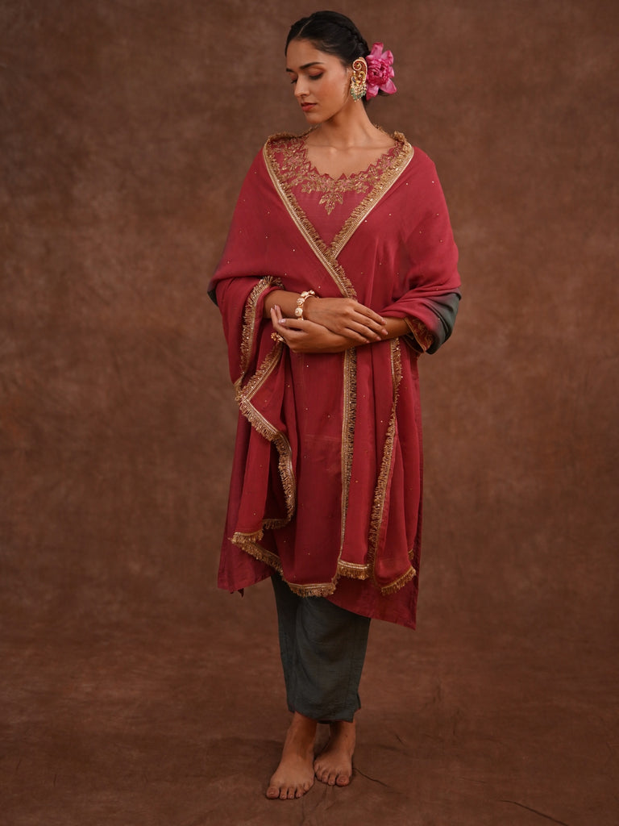

Indian Bridal Outfit vs Wedding Wear for Women Guests
An indian bridal outfit usually has a different visual responsibility from an outfit worn by a guest or relative. Bridal dressing can be more elaborate because the bride is central to the celebration and photographs. Guests and family members can still look luxurious and occasion-appropriate without choosing a look that feels unnecessarily heavy.
For guests, versatility is especially valuable. A polished kurta set, Anarkali, kaftan, or other coordinated ethnic ensemble can work beautifully when the design has enough festive detail but remains comfortable for movement. Close family members may prefer to invest in one or two stronger statement looks for the main ceremony and reception, then keep the remaining outfits easier to style.

Choose Indian Wedding Wear Dresses for Women by Function

Haldi and Mehendi
Daytime functions such as Haldi and Mehendi usually benefit from an outfit that allows easy movement and feels comfortable for long periods. Colour can do much of the styling work here. Bright or cheerful shades can create a festive mood without requiring heavy embellishment. Look for silhouettes that let you sit, move, participate in rituals, and still feel put together.

Sangeet and Cocktail Celebrations
Sangeet and cocktail evenings are ideal for Indian outfits for women wedding events that combine traditional details with a more fashion-forward finish. Rich colours, refined embroidery, interesting necklines, coordinated separates, and elegant draping can all work well. Since these events often involve considerable movement, make sure the outfit is as wearable as it is visually striking.

Engagement and Family Celebrations
An engagement or formal family gathering is a good place for a polished, sophisticated ensemble. Silk-based sets, structured Anarkalis, refined festive sets, and other elevated ethnic silhouettes can create a dressed-up appearance without making the outfit feel reserved only for the wedding day.

The Main Wedding Ceremony and Reception
For the main ceremony or reception, your outfit can carry more visual depth. This is where richer fabrics, detailed embroidery, deeper colours, or more elaborate silhouettes can feel appropriate. If you are part of the immediate family, consider putting a larger share of your wardrobe budget into this look because it is likely to be photographed heavily.

How to Choose the Right Silhouette
Indian wedding wear for women now spans much more than one traditional format. The current wedding-wear collection at World of Sugandh includes kurta sets, Anarkali sets, kaftans, gowns, lehengas, sharara sets, co-ord sets, and other occasion-led styles. That variety means you can choose according to the function and the kind of movement you expect rather than forcing every occasion into the same silhouette.

Kurta Sets for Versatility
Kurta sets are especially useful when you want a complete ethnic look with styling flexibility. Coordinated bottoms and, where included, a dupatta can make dressing straightforward, while jewellery, footwear, and layering can change the overall impression.

Anarkali Sets for Graceful Occasion Dressing
Anarkali silhouettes naturally create a flowing, occasion-ready appearance. They can work particularly well when you want a feminine, dressed-up look without moving into heavily structured bridalwear.

Kaftans and Contemporary Silhouettes
Kaftans can offer an elegant alternative when you want ease and visual impact together. They are useful for festive gatherings, wedding-related dinners, and celebrations where comfort matters. Contemporary silhouettes can also help you avoid buying a wardrobe that feels too repetitive.

Lehengas and Sharara Sets for a More Traditional Statement
When the occasion calls for a stronger traditional statement, lehengas and sharara sets can bring more ceremony to the look. They are best selected with the event, venue, and expected dress level in mind rather than simply because they look festive online.
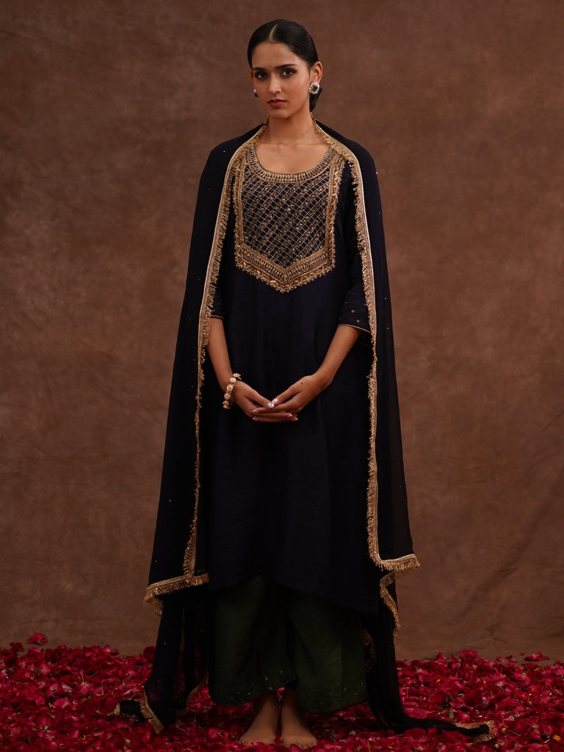

Product-Inspired Picks from the Wedding-Wear Collection
The following examples are drawn from the supplied wedding-wear collection and verified product-page information. They are included because their actual colours, fabrics, silhouettes, and design details make them useful examples of different wedding looks.

Mrigja Chand Kurta Set
Mrigja Chand is a three-component regular-fit set with silk used for both the top and bottom. The product page lists beige as the colour and a round neckline. Its description highlights a mauve short kurta with subtle golden dots paired with deep maroon embroidered pants, giving the outfit contrast without relying on a single colour. The combination makes it a strong example for someone looking for Indian wedding wear that feels traditional while retaining a contemporary colour story.

Ruhani Red Silk Kurta Set
Ruhani Red Silk Kurta Set is a three-component regular-fit ensemble listed in maroon, with silk for both the top and bottom and a round neckline. The product description features golden geometric threadwork along the neckline and front panel, along with soft golden pants and a sheer red dupatta with subtle sparkle. These details give the set a distinctly celebratory character for a formal wedding function or grand festive evening.

Gulmohar Silk Kurta Set
Gulmohar is a three-component regular-fit silk set with a V-neckline and a wine-toned colour story. The product description notes gold and pink floral detailing on the sleeves, a finely edged golden neckline, and ash-grey pants with coordinating accents. The contrast between wine and grey makes it useful for someone who wants wedding dressing to feel sophisticated rather than overly bright.

Gulmitti Silk Kurta Set with Dupatta
Gulmitti is a three-component regular-fit silk set listed in pink, with a round neckline. Its product description describes a Raspberry Pink kurta with gold embroidery around the neckline and sleeve cuffs, paired with coordinating beige or tan pants. The product title identifies it as a silk kurta with dupatta, making it a natural option when you want a more complete traditional wedding look with a strong colour accent.

Gulchaand Rose Pink Silk Kurta Set
The Gulchaand Kurta Set is a three-component regular-fit silk ensemble listed in pink with a V-neckline. The product description highlights a wine-red kurta with delicate golden leaf-like detailing around the neckline and sleeves, paired with grey pants. Its classic colour combination and gold accents show how a controlled palette can still look distinctly festive.

How to Style Indian Outfits for Women Wedding Events
Once the outfit is chosen, styling should support rather than compete with it. If the garment already has visible embroidery or metallic detailing, jewellery can be kept more focused. A statement earring, refined bracelet, or elegant ring can often be enough.
For simpler outfits, accessories can create the occasion effect. A detailed dupatta, festive footwear, traditional jewellery, or a structured bag can shift the same base outfit from a relatively simple look to a wedding-ready ensemble. This is one of the easiest ways to increase the number of occasions a single piece can serve.

Build a Colour Strategy Instead of Buying Randomly
A useful wedding wardrobe is easier to style when the colours have some relationship with one another. You do not need every outfit to match, but a balanced mix of deep tones, soft neutrals, bright festive shades, and one or two statement colours can give you more options across several functions.
If you already own a favourite dupatta or a versatile pair of festive shoes, use those pieces as anchors while shopping. This keeps new purchases connected to what you already own and makes mix-and-match styling much easier.
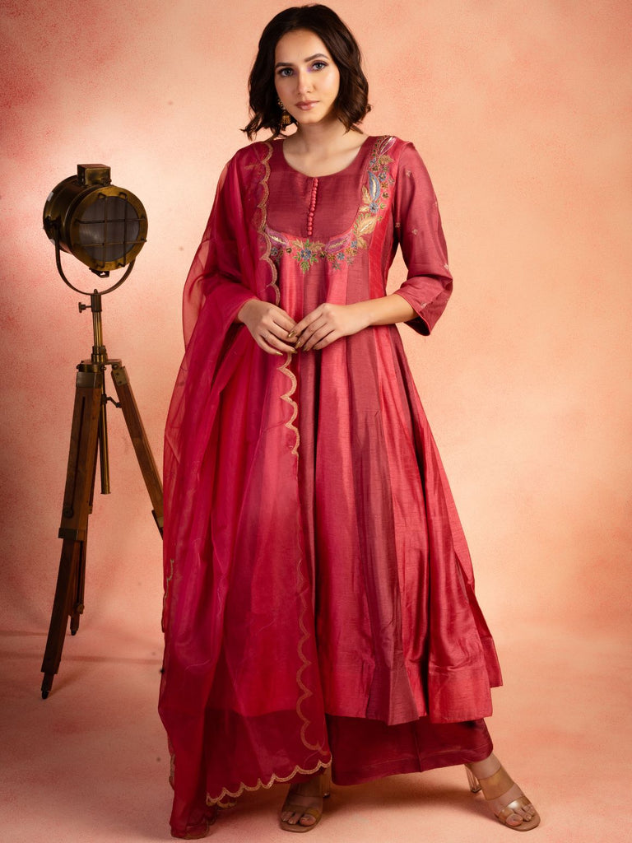

Budgeting for Wedding Wear for Women
Wedding shopping becomes much easier when you treat it as one overall budget rather than a series of unrelated purchases. Start by listing every function you will attend and then decide which events deserve your strongest investment.
- Reserve the largest share for the main ceremony or reception if you expect it to be the most photographed event.
- Choose comfortable but polished outfits for functions that involve a lot of movement, dancing, or daytime activity.
- Avoid spending heavily on every function when a well-styled, re-wearable outfit can serve more than one occasion.
- Keep a small buffer for accessories, tailoring, footwear, or last-minute styling changes.

Think About Re-Wear Before You Buy
One of the smartest ways to shop Indian wedding wear dresses for women is to imagine the outfit after the wedding season. Could the same kurta set work for a festive dinner? Could the dupatta be styled with another outfit? Could the jewellery be used for a family celebration or puja? If the answer is yes, the outfit has more long-term value.
This does not mean every wedding outfit has to be understated. It simply means that even an occasion-focused purchase can be chosen with future styling in mind. Pieces with strong colour, elegant detailing, and adaptable silhouettes often have more opportunities for re-wear.

Common Mistakes to Avoid When Buying Indian Wedding Wear for Women
- Buying only heavily embellished outfits and then discovering you have nothing suitable for daytime functions.
- Choosing a fabric or silhouette purely because it looks impressive in photographs without considering comfort and weather.
- Ignoring the size chart and fit information, especially for structured or fitted silhouettes.
- Buying separate outfits for every function without considering whether accessories or styling can create a fresh look.
- Choosing an outfit without considering your role in the wedding and the level of formality expected.
- Waiting until the last minute to plan outfits for a multi-day celebration.

A Simple Wedding-Wear Shopping Checklist
- Identify the function and time of day.
- Decide how formal your role requires the outfit to be.
- Choose the silhouette before getting distracted by colour or embellishment.
- Check fabric, fit, neckline, components, and available sizing information on the product page.
- Consider whether the outfit can be styled differently for another occasion.
- Plan jewellery, footwear, and outer layers before finalising the purchase.
- Leave enough time for fitting, alterations, and outfit preparation.

Frequently Asked Questions

How is an indian bridal outfit different from regular wedding wear for women?
An indian bridal outfit generally carries greater visual emphasis and may use richer detailing, more elaborate construction, or stronger ceremonial styling. Guest and family wedding wear can be festive and elegant while remaining more versatile and comfortable.

How many Indian wedding wear dresses for women do I need?
There is no fixed number. Start with the functions you are actually attending, then plan one stronger outfit for the most important event and use versatile pieces or restyling for the remaining celebrations.

What should guests prioritize when buying Indian outfits for women wedding events?
Guests should prioritize comfort, versatility, fit, and an appropriate level of occasion dressing. A well-chosen outfit that can be restyled is often more useful than several single-use pieces.

Can women’s ethnic wear for weddings and parties be reused after wedding season?
Yes. Silk sets, elegant kurta sets, Anarkalis, kaftans, and other versatile festive pieces can often be restyled with different jewellery, footwear, dupattas, or layering for later celebrations.

Which fabric should I choose for wedding wear?
Choose according to the occasion, weather, silhouette, and comfort you need. Check the exact product page for the fabric of the style you are considering.

Final Thoughts
The best Indian wedding wear for women is not simply the most embellished outfit in the room. It is the outfit that fits the occasion, suits your role, feels comfortable enough to enjoy the celebration, and gives you styling possibilities beyond one day. From silk kurta sets and Anarkalis to kaftans, lehengas, and contemporary occasion styles, the right choice depends on how you want to feel and how you plan to use the piece.
Approach wedding shopping with a clear function-by-function plan, a realistic budget, and an eye for re-wear. When the outfit, fit, colour, fabric, and styling all work together, getting dressed for every celebration becomes much simpler and your wedding wardrobe feels considered rather than crowded.

